*Business proposal 2015*

DigiRAMP is seeking seed capital to reach first 30,000 beta users and 50,000 songs in 6 months.



Creators and owners of music need a better way to market their work and collect their fair share of revenues.

DigiRAMP provides control of rights, assets and revenue streams to the appropriate parties.

Artists and businesses now have the power to build an entire supply chain in a transactional market place: DigiRAMP.

Music consumers can now transact directly with the artists and rights owners, with transparency and direct, instantaneous accounting to all stakeholders.

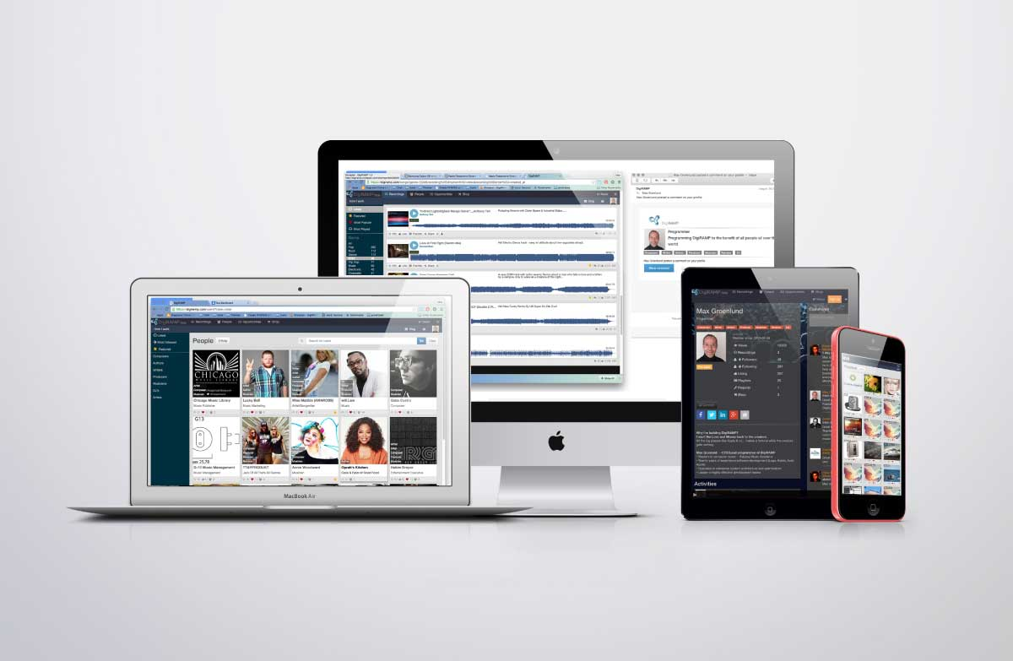

Table of content

DigiRAMP is founded by 4

Peter Rafelson 4

Max Grønlund 4

Why 4

Users 4

Features 4

Business model 5

The Industry 6

Status 7

6 month goal 7

7-18 month goal 7

We offer 7

Budget 9

# DigiRAMP is founded by

## Peter Rafelson

Veteran music businessman, composer, producer, musician and the creator of over thirty #1 songs, Peter has produced a massive catalog of 5,000+ masters

Peter owns five companies including publishing and record labels.

## Max Grønlund

Software architect, programmer, designer, IT Management:

Lego, Avid, Apple, Koblo, KeyToSound

Max invented the first Software “Virtual instruments” and Virtual DAW.

Max has also engaged with many of the most successful recoding artists as the CEO of Koblo

# Why

Today’s distribution channels provide close to no income to the creators of music.

Yesterday’s distribution channels are ineffective and expensive.

Writers and Artists are forced to accept big companies making big money from their music just so they may be distributed and heard.

# Users

Writers, Musician’s, Fans, Indie labels, Lawyers, Representatives and many more…

Can all fulfill their needs to connect and exchange value, services and products with respect to all rights holders and all receive revenue for their work and interests.

# Features

DigiRAMP is cloud-based solution where all users can:

Identify, listen to and license music.

Buy and sell products and services.

Upload recordings

Manage rights

Distribute revenue streams to all stakeholders

Collaborate

Connect and promote to social media

Professionals can subscribe to advanced features, which let them manage companies, employees and recording catalogs in bulk.

# Business model

DigiRAMP takes a rake on all transactions - the rate varies from 1.9% to 20% depending on the amount of each transaction, the greater the transaction is the lower the cut.

DigiRAMP offers Pro Accounts at $19.95 a month and Business accounts at $159.00/mn.

The Industry

The business of Music is growing at an astronomical rate and has never seen so many people spend money on music as they do now. The annual growth has been 10% for the last year. Music is big business - just *not* for the creators.

But:

Creators get only 0.00019 cents per stream.

Apple only pays artists when a threshold of $100 is reached.

Popular artists such as Prince are receiving only a fraction of income for their catalogs on services such as Spotify, Pandora, etc…

SoundCloud is not paying writers for use of their work.

It’s safe to say that most artists and writers rarely receive any compensation at all.

# Status

DigiRAMP is currently in beta

1275 users

3,000+ recordings

5 Pro accounts

No significant burn rate

Lots of industry contacts

Backend can scale to 100.000 users with no slow-down

Unlimited storage & bandwidth

# 6 month goal

Grow the user base to 16k users and the content to 50,000+ recordings

Sell 320 Pro accounts

Develop account-streaming service and deploy shops for sale of products & services

Ramp up the staff with user support

Sign deals with independent labels/grow volume of recordings

Prepare technology for unlimited traffic and users

# 7-18 month goal

Grow users and content by 400%

Develop a pro streaming service (paid subscription model)

Make distribution and retail deals with additional, larger labels and catalogs

Create a DigiRAMP label, which can also aggregate rights and assets.

Improve user experience/workflow

Consolidate market position as a leader in rights and asset management

# We offer

100 Convertible Equity Certificates (A) for convertible stock sold in batches of 5, each note cost $ 2,500 so minimum is: $12,500

100 convertible equity certificates (B) for convertible stock sold for $3000, each.

A and B certificates will convert to 130% at A round

The convertible equity certificates will be offered on a monthly basis:

Starting:

Oct. 2015

3 (a) Certificates

10 (b) Certificates

For more information please contact

Peter Rafelson

peter@digiramp.com

# Budget

Sep 2015 - Feb 2016



# Production plan



# References

<https://digiramp.com/>

<https://www.youtube.com/watch?v=lOCJL2M3IzM>

<https://www.youtube.com/watch?v=fY7_zPXcmNk>

[www.musicintofilm.com](http://www.musicintofilm.com)

<http://missmatildablog.com/qa-with-peter-rafelson-digiramp/>

<http://www.digitalmusicnews.com/2015/08/13/soundcloud-faces-massive-legal-action-before-thanksgiving-sources-say/>

<http://www.digitalmusicnews.com/2015/08/05/soundcloud-could-become-the-next-grooveshark-sources-say/>

<http://www.billboard.com/articles/business/6655915/how-the-blockchain-could-actually-change-the-music-industry>

<https://www.techdirt.com/blog/casestudies/articles/20130529/15560423243/massive-growth-independent-musicians-singers-over-past-decade.shtml>

<https://www.techdirt.com/articles/20150204/07310329906/yes-major-record-labels-are-keeping-nearly-all-money-they-get-spotify-rather-than-giving-it-to-artists.shtml>

<http://www.ifpi.org/consumer-research.php>